# BMET5790: Biomechatronics

# ACTIVITY: EMG Signal Processing

Tick your name

Name:_______________________ SID:____________________ _____

Name:_______________________ SID: ____________________ _____

Name:_______________________ SID: ____________________ _____

Live [ ] Remote [ ]

Note: Activity needs to be completed and submitted by the end of the lab

## Hardware

|  |  |  |
| --- | --- | --- |
| Item | Reference Number | Returned (signed by Tutor) |
| DT9835 Module with PSU and USB cables |  |  |
| B&L Eng 6 channel EMG interface module |  |  |
| B&L Eng EMG pre-amplifier |  |  |
| Short BNC cable (Pigtail) |  |  |
| Computer running DT Measure Foundry |  |  |
| Electronic scale |  |  |

## Reading

5.4.2 Analog Filters

10.9.4.3 Myoelectric Signals (again)

## Background

This activity in the EMG/Robot Arm Control series aims to introduce some of the possibilities for processing the raw EMG signals

## Setting up the Activity



**Figure 1: Wiring for the EMG Activity**

The EMG amplifier is plugged into the B&L interface module. This connects battery power to the amplifier, and connects the amplifier output to the BNC socket

Channel 1 of the B&L interface module is connected to AD Ch0 through the short BNC cable

Ground terminal from the Interface Module and the subject’s wrist band

The USB port from the PC is plugged into the DT module

DT module plugged into a USB port of the PC

Power is provided to the DT module

Electronic kitchen scales (not shown in the figure) are used to measure the applied force

## Developing the Measure Foundry Software

If you are a remote student you will not be able to do this, so I have done it on your behalf, as seen in Figure 2.



**Figure 2: EMG screen capture showing two channels of muscle contraction and some simple signal processing**

**Part 1: EMG Force relationship (Live Students)**

Watch the Video *EMG tests.mp4* to find out how the measurements are conducted

Setup the hardware as shown in Figure 1

Download EMG Monitor.MFproj and run the software and confirm that the display looks something like the one shown in Figure 2 (10)

Display your version of the MF project captured screen here

Attach an EMG amplifier to your triceps using a rubber band and attach a ground strap to your wrist, as shown in the video

As you push down on the scales, confirm that changes in the applied force are registered as changes in the envelope trace and the mean signal level

1. Block diagram of whats going on. What are each of the displays showing? (6)

Display the new captured screen illustrating the improvements

1. Justify this additional filtering (5)

Justification for additional filtering

1. Slowly increase the applied force applied, while you partner logs both the force and the mean signal in this table (10)

|  |  |  |  |  |
| --- | --- | --- | --- | --- |
| Force (kg) | Mean Envelope Voltage (V) |  | Force (kg) | Mean Envelope Voltage (V) |
| 0 | 0.63 |  | 3.5 | 1.82 |
| 0.25 | 0.5 | 3.75 | 1.87 |
| 0.5 | 0.5 | 4.0 | 2.47 |
| 0.75 | 0.5 | 4.25 | 2.79 |
| 1.0 | 0.5 | 4.5 | 3.09 |
| 1.25 | 0.53 | 4.75 | 3.25 |
| 1.5 | 0.57 | 5.0 | 4.41 |
| 1.75 | 0.65 | 5.25 | 4.14 |
| 2.0 | 0.71 | 5.5 | 5.13 |
| 2.25 | 0.80 | 5.75 | 4.10 |
| 2.5 | 1.02 | 6.0 | 5.60 |
| 2.75 | 1.13 | 6.25 | 5.82 |
| 3.0 | 1.31 | 6.5 | 5.87 |
| 3.25 | 1.62 | 6.75 | 6.48 |

1. Plot the relationship between the applied force (kg) and the EMG signal envelope (V), and annotate appropriately (5)
2. Fit a 2nd order polynomial to the measurement data, and plot the two graphs on the same axes. (5)
3. Can you suggest any reason that the relationship is slightly nonlinear, with the EMG signal increasing exponentially with increasing applied force? (2)

Fatigue could increase muscular activation over time. Isometric holds recruit larger amounts of muscle fibres.

Subtotal (43

**Part 2: EMG and Muscle Fatigue (Live Students)**

In this section you will be examining the relationship between the EMG signal and muscle fatigue. Look at the video to see how it is done

1. Using two of the 1.5kg diver’s weights provided, measure the muscle activity on the biceps as a function of time. Your partner should complete the following table. Swap to obtain data from both parties (10)

|  |  |  |
| --- | --- | --- |
| **Time (s)** | **Caleb (3kg)** | **Hunter (4.5kg)** |
| 0 | 7.7 | 8.9 |
| 10 | 5 | 6.6 |
| 20 | 7 | 7 |
| 30 | 7.5 | 7.3 |
| 40 | 4 | 7.1 |
| 50 | 6.6 | 7.5 |
| 60 | 5 | 6 |
| 70 | 6 | 7 |
| 80 | 6.5 | 8 |
| 90 | 4.5 | 8 |
| 100 | 4.6 | 7 |
| 110 | 6.2 | 9.5 |
| 120 | 6.7 | 9.5 |
| 130 | 4.5 | 10 |
| 140 | 4 | 9.2 |
| 150 | 3.7 | 10 |
| 160 | 4.4 | 10.5 |
| 170 | 5 | 8.1 |
| 180 | 5 | 11.1 |
| 190 | 4.68 | 13 |
| 200 | 5.4 | 11 |
| 210 | 6.1 | 10 |
| 220 | 5 | 11 |
| 230 | 4.6 | 11 |
| 240 | 6 | 13 |

1. Plot a graph of the mean EMG signal amplitude (v) against time (s) for both people (5)
2. Comment on differences between the data obtained for the two people and justify them in terms of the participants size and fitness level. (5)

Participant 1 was greatly superior and failed to fatigue even at 4 minutes. However, participant 2 wasn’t a bitch and used more weight. The hustle demonstrated by participant 2 should be admired and participant 1 should learn from him. Participants 1 and 2 were similar in size although participant 1 is fitter.

1. Comment on the relationship between the EMG signal envelope and the time. (2)

Due to the increased weight, participant 1 demonstrated more fatigue and higher muscle activation as time progressed. There was also a positive offset due to the increased weight.

1. Would it be possible to infer real muscle fatigue from the level of the EMG signal (y/n)? Briefly justify your answer. (1)

No because EMG data is influenced by a variety of factors e.g increased weight, participant strength, external conditions as well as the time under tension. However, it may not be visible in the time domain but in the frequency domain there may be identifiable changes

Subtotal (23)

**Part 3: EMG Transition Slope (Live Students)**

In this section you will be examining the use of changes in the amplitude of the EMG signal with time to trigger different modes in a prosthesis

Read Section 10.9.4.4 in the Biomechatronics book to inform your understanding of the process

1. Keeping the electrode on the biceps and using the existing project, generate three different outputs showing slow, medium and fast force transitions. Capture the screen and label the transitions (8)

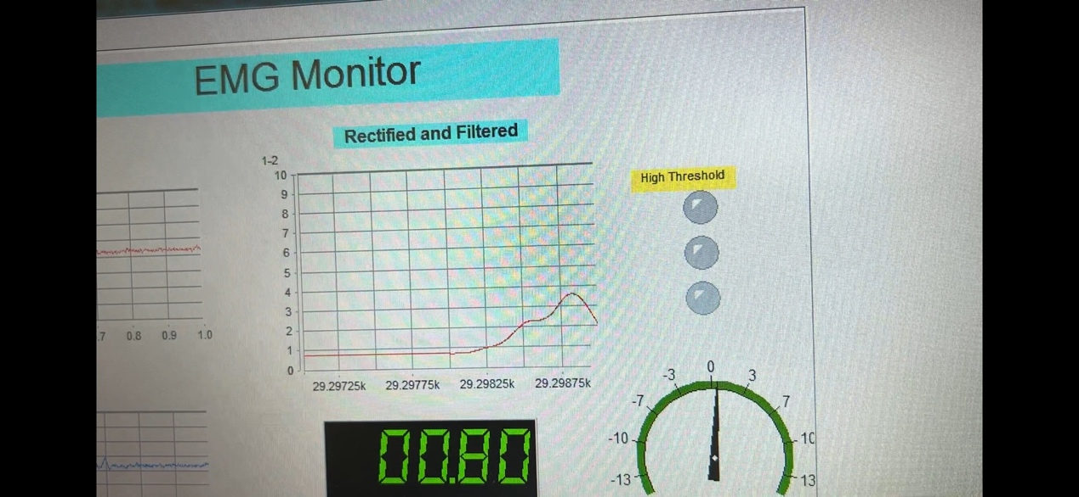



Slow

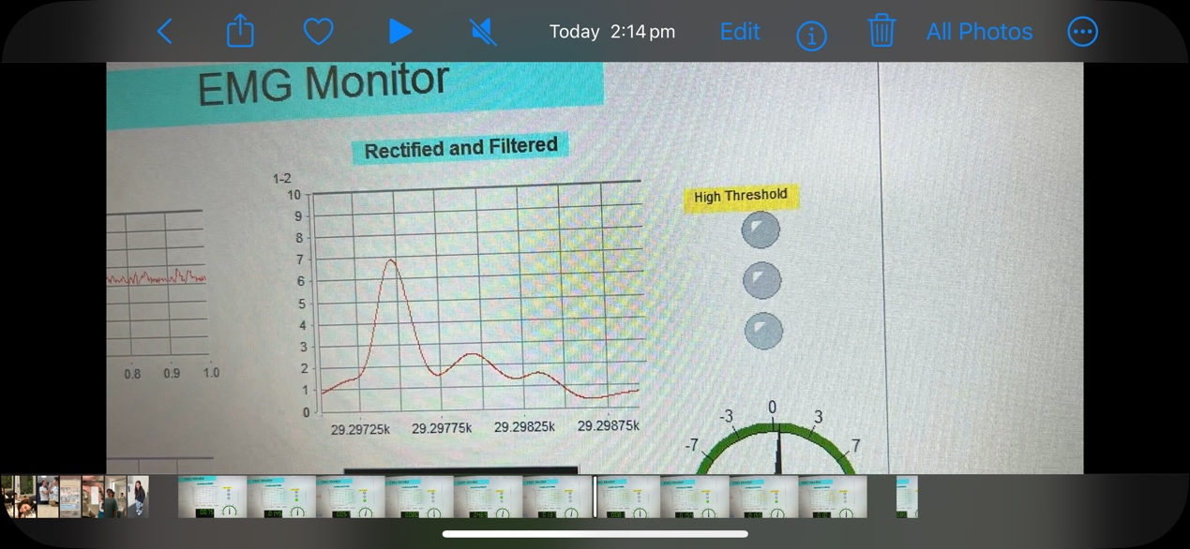



Medium

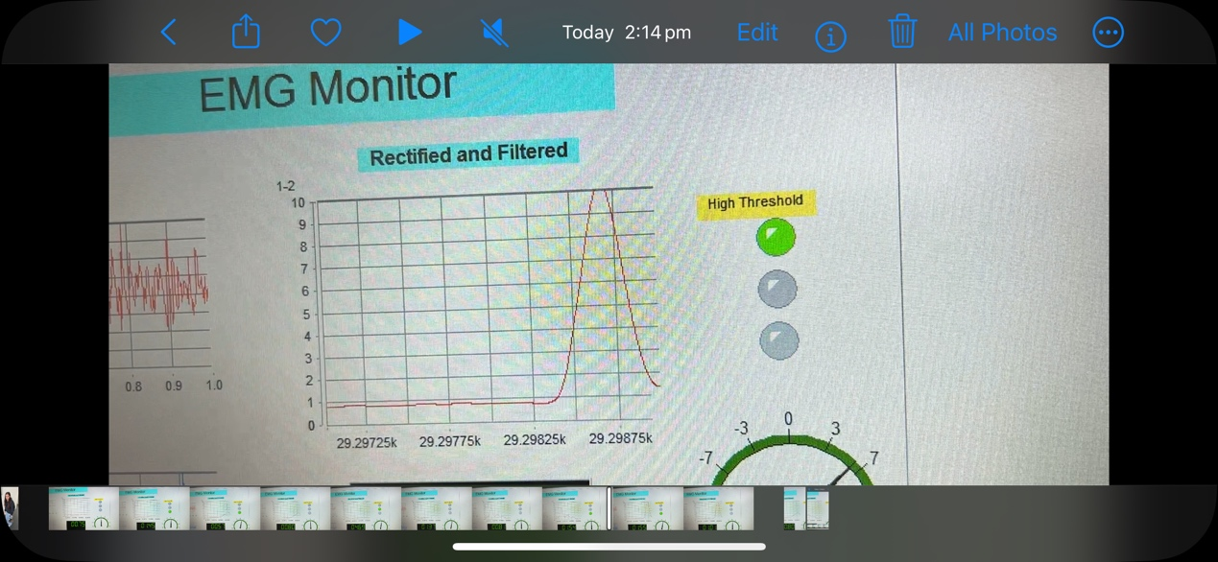



Fast

1. With any processing you wish to apply in Measure Foundry, see whether it is possible to illuminate individual LEDs based on these transitions. Include a screenshot or shots showing your results (15)

Did this

1. Describe the algorithm you used to perform this function (5)

Subtotal (28)

**Part 4: EMG Transition Counts (Live Students)**

In this section you will be examining the use of rapid transitions in the EMG signal to trigger different modes in a prosthesis

1. Keeping the electrode on the biceps and using the existing project, generate three different outputs showing a number of rapid repeated force transitions transitions. Capture the screens for 1, 2 and 3 transitions and label the transitions (8)

Insert your annotated graph/graphs here

1. Describe the algorithm you would use to perform this function (5)

Description

Subtotal (13)

Total (107)